# **1.1.[Develop Your Soft Skills](https://openclassrooms.com/en/courses/6951366-develop-your-soft-skills)**

Have you heard of **soft skills,** also called **transferable** skills? They include decision-making, collaboration, emotional intelligence, critical thinking, creativity, organization, service orientation, communication, etc. Soft skills are necessary to successfully **adapting** to changes in the professional world, **interacting others,** or **solving complex problems.** They are useful for all professions and have ever-increasing value in the job market.

Do you want to develop these skills? Then you’re in the right place! In this course, you’ll explore **why soft skills are essential** for your future career. You will then complete a **self-assessment** and identify your strengths and areas you can improve. Finally, you will create an **action plan** to develop the soft skills that will allow you to accomplish your goals.

Let's get started!

**Learning Outcomes**

At the end of this course, you will be able to:

* Identify why soft skills are essential.
* Self-assess soft skills.
* Create an action plan to develop soft skills.

## **Get the Most Out of This Course**

### **Meet Your Teachers**

### **Get to Know the Structure of the Course**

### **Ever considered an OpenClassrooms diploma?**

* Up to 100% of your training program funded
* Flexible start date
* Career-focused projects
* Individual mentoring

**Find the training program and funding option that suits you best**

## **1.2.Start Your Soft Skills Exploration**

Making decisions, managing emotions, communication, and organization have one thing in common: they are skills, and you have the power to **develop** and **nurture** them. They are called ***soft skills*** and are very much in demand.

According to the World Economic Forum, the ten most in-demand skills in the job market are considered "soft." For more information, read [**this article**](https://www.weforum.org/agenda/2016/01/the-10-skills-you-need-to-thrive-in-the-fourth-industrial-revolution/)**.**

This chapter explores your skill set in a little more detail, starting with a self-assessment: where are you with your soft skills?

### **Assess Your Skills**

This assessment aims to help you become aware of your behavior and observe how you react in certain situations. There are no right or wrong answers. To keep track of your responses, you can use [**your guided journal**](https://s3-eu-west-1.amazonaws.com/course.oc-static.com/courses/6951366/Guided%20journal%20-%20Part%201%20-%20Soft%20Skills.docx) or just a paper and pen. Answer straight away without thinking too much about it.

Decision-making

**You want to change jobs, and after two interviews for two different companies, both of them call you back to offer you a position. Faced with this important decision:**

* It's generally a formality; you don't think too long and are ready to make your choice.
* You take a relatively long time to think about it.
* Most of the time, you ask for help or advice.
* You have great difficulty deciding, sometimes to the point of missing an opportunity.

Communication

**Speaking, whether in an interview or presentation, is:**

* A real pleasure – no need for preparation, you like to improvise.
* A challenge that you're ready to take on but that requires some preparation.
* Quite complicated – you've always been a little shy when speaking.
* Truly paralyzing - you might not sleep the night before the event.

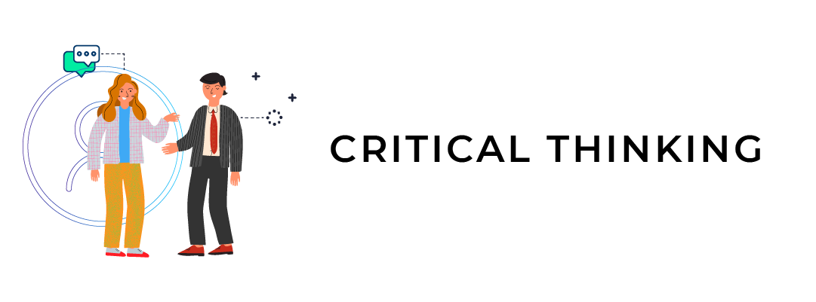Critical thinking

**Your colleagues are debating a current issue and disagree. When it's your turn to offer your opinion:**

* You learn about the topics using verified sources.
* You try to present your point of view in a way that won't offend anyone.
* You say as little as possible. The less one knows about your opinions, the better off you are.
* You agree with the person who appears the most knowledgeable.

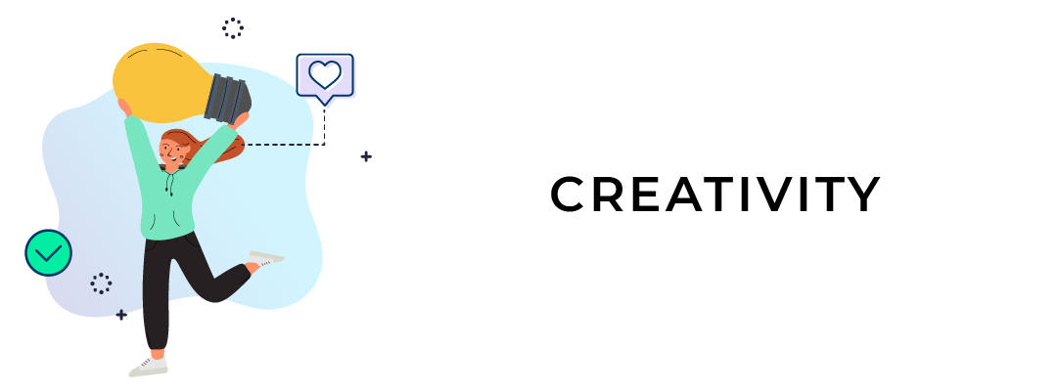Creativity

**Creativity is:**

* A skill that can be nurtured daily and applied to a large number of professions.
* A skill only used in certain occupations.
* Artistic talent.
* A collection of ideas that already exists.

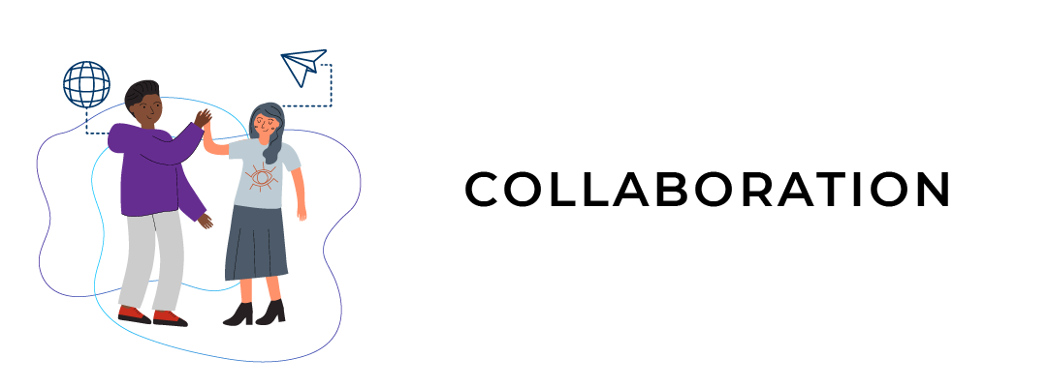Collaboration

**When someone (or a group) offers to collaborate with you:**

* It's not a problem – you love discussing and co-creating projects with others. You'll go ahead without asking too many questions.
* You tend to ask about who you'll be working with. You try to avoid surprises.
* The very idea of collaborating tends to stress you out, and you hesitate.
* You try to avoid collaboration.

Service orientation

**A new colleague joins your team. What's your reaction?**

* You go directly to them and let them know how the team works and your role.
* You let them find their place and offer help and advice.
* You greet them and wait for them to come and ask you questions.
* You don't allow the disruption and go ahead with your work.

Emotional intelligence

**When faced with a situation that makes you angry or scares you, you tend to:**

* Let the emotion control you.
* Take a little time to breathe and get some perspective on the situation so you can manage your feelings.
* Try to ignore your emotions.
* Are pessimistic, resenting others for a while.

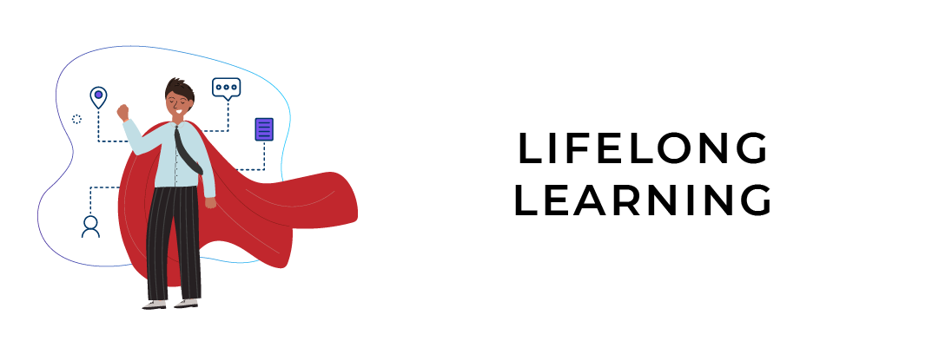Lifelong learning

**You think it's possible to learn:**

* From every life situation that you go through, whether you fail, succeed, or face obstacles.
* Primarily when you're young, at school, with teachers.
* Much better when you're alone.
* By interacting with others.

Organization

**In terms of organization, you tend to:**

* Be very well organized.
* Have difficulty prioritizing.
* Want to do several things at the same time.
* Quickly panic.

Have you finished?

By taking stock of your behaviors and reactions, you have started the **learning process of developing your soft skills.** OpenClassrooms courses can help you improve your decision-making, communication, critical thinking, creativity, collaboration, service orientation, emotional intelligence, lifelong learning, and organization skills.

Now think about your previous answers:

* Which scenario appeared the most difficult for you?
* Which situations made you feel most comfortable?

By asking yourself these questions, you are identifying the behaviors and habits that you can change. And soon, you'll know how to transform them into skills.

### **Define Soft Skills**

What are soft skills?

Soft skills are **personal and interpersonal behaviors.** You may not have learned them in school, but you use them every day. For example, they include adaptability, communication, decision-making, creativity, or even managing your emotions.

American academia was the first to introduce the idea of soft skills. About ten years ago, the concept showed up in French business vocabulary and higher education. This skill set can also be called transversal (formally called transferable) or behavioral skills.

Why is it essential to develop these skills?

Soft skills make it easier to efficiently cope with **personal and professional challenges** and improve **relationships** with others. They make you more independent, and at the same time, help develop your inner strength and curiosity about situations and your reactions to them.

The good news is that they are **accessible** to anyone who wants to put in the effort to develop them.

### **Let's Recap!**

In this chapter, you have:

* Assessed your soft skills and noted how you react in certain situations.
* Defined what soft skills are: behavioral skills that are essential to facing personal and professional challenges.
* *Over the rest of this course, you'll discover that each professional or personal difficulty is an opportunity to develop your soft skills, especially in a changing work environment. What are these changes? You'll find out in the next chapter!*

## **1.3.Prepare for Changes in the World of Work**

If the world is becoming more digital, why are soft skills so necessary?

Great question! **Digitization** pushes us to **continually adapt** to new tools, practices, and ways of interacting. Additionally, we also have to face new challenges, which we'll explore together.

#### **Challenge No. 1: Task Automation**

**Task automation** and the rise of **artificial intelligence** involve rethinking the way people work.

According to the World Economic Forum, in 2018, about 71% of work was done by humans and 29% by machines. In **2022,** they estimate that the gap will be less: **humans will do** **58** **% of the work, and machines will do 42** **%.**

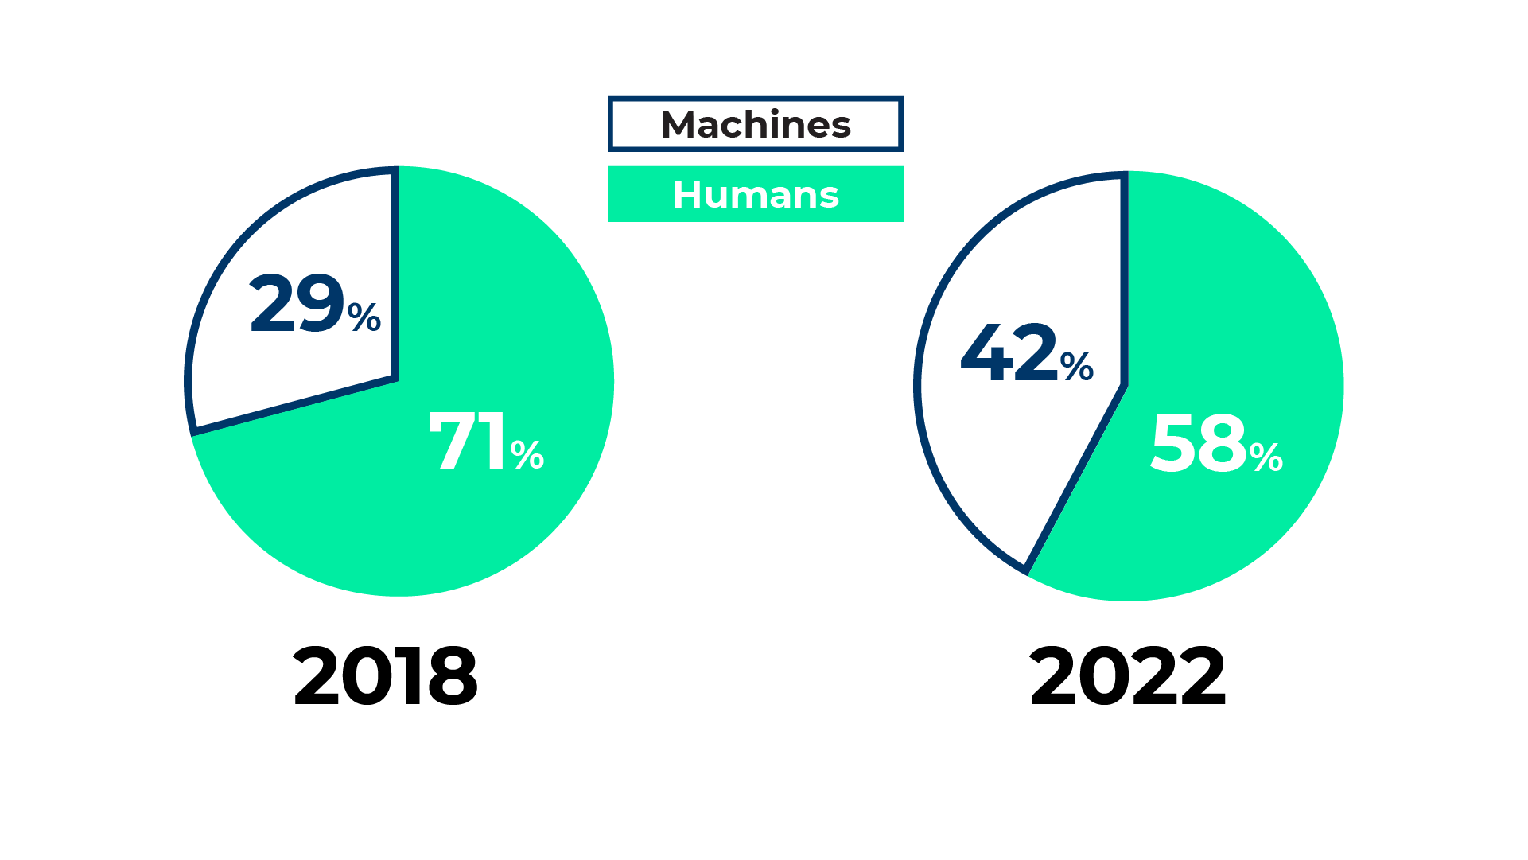World Economic Forum

Does that mean that all of our work is going to be replaced by machines or robots?

No, but most definitely a part of it! **Repetitive and difficult tasks** that don’t require creativity will probably be **automated.**

But there are skills that machines cannot replace: **human (soft) skills.**

As industries automate tasks, it provides an excellent opportunity to focus on what humans bring to the table: knowing how to think, appeal to the analytical mind, stimulate collective intelligence, solve complex problems, adapt to the emotions of others, etc. All of these skills are already valuable today, and they will become even more so tomorrow.

#### **Challenge No. 2: The Acceleration of Time**

You may have noticed that tools, technologies, and practices evolve faster and faster.

For example, to meet consumer expectations and demands, online shops now deliver orders the same or next day.

People also don’t consume the same way they did a few years ago, and there are several reasons why.

Have you noticed that your mobile phone starts having glitches after around two years?That’s **planned obsolescence.** The idiom,“They don’t make ’em like they used to,” is correct. This practice requires consumers to buy new equipment (computers, mobile phones, tablets, light bulbs, etc.) more often than previous generations.

Planned obsolescence also applies to careers. In the past, workers would stay at the same company for their entire career. That’s not true today. The current generation will **change companies** much faster (and more often) than previous ones.

**Ultra-responsiveness** and **rapid adaptation to changes** become the norm.

Dealing with this acceleration of time requires learning quickly and efficiently, and knowing how to be flexible.

#### **Challenge No. 3: Uncertainty, the Unknown**

According to a study by Dell and the Institute for the Future, **85** **% of the jobs for 2030 are unknown.** Whether these forecasts are accurate or not, they invite us to reinvent our relationship to work and the future.

Here are some examples of new professions that have emerged in recent years: chief digital officer, growth hacker, brand content manager, UX designer, etc. You certainly know others. Maybe you'll even invent your own profession!

As mentioned, you are probably not going to work for the same company your entire career. Today, **career paths are less and less linear.** Your professional experiences and abilities will be increasingly more **diversified.**

For example, if you work for a start-up, you'll probably wear several hats and have various responsibilities. You will need to be **agile** - and show that you can quickly change tasks and work **independently.**

If you work in a large group, you'll undoubtedly help update work methods and processes, some of which have been around for decades.

#### **Challenge No. 4: The Complexity of the Problems To Be Solved**

Society is facing several significant challenges that also impact companies.

* **Environmental issues:** global warming, plastic pollution, depletion of natural resources, loss of biodiversity, etc. have been getting worse over the past 30 years. These issues question the current economic model: *why* and *how* companies produce the way they do.
* **Social issues:** social inequalities have exploded over the past 30 years.

According to [**Oxfam**](https://www.oxfam.org/en/5-shocking-facts-about-extreme-global-inequality-and-how-even-it)**,** 82% of the wealth created in 2017 benefited 1% of the world's population.

This data questions the impact that organizations and companies want to have on the world: how are they participating in creating a more just and equitable society?

For organizations to face these complex problems, they need to question their practices and look for lasting solutions. One example is how companies had to **adapt to the COVID-19 crisis that forced the world to reinvent itself quickly.**

Okay, but what does that have to do with soft skills?

For organizations to solve complex problems and adapt to change, they need **innovative and inspiring** leaders who can demonstrate **critical** thinking, **communication skills,** and **self-confidence** to look at different views. In other words, they need people with soft skills.

But don't just take our word for it. Watch our interview with **Dr. Marcia Goddard**, an expert in social neuroscience, to gain more insight into the relationship between change in the workplace and the development of soft skills.

#### **Let's Recap!**

In this chapter, you explored four challenges:

* Task automation and artificial intelligence will make **technical skills obsolete** and bring back **human skills.**
* **The acceleration of time** pushes us to continue to adapt at a growing rate.
* **Uncertainty and the unknown** create careers that are increasingly less direct.
* Organizations face **complex social issues** and need professionals with soft skills to meet them.

*What are the skills recruiters are looking for? We'll explore that in the next chapter.*

## **1.4. Discover Sought-After Job Skills**

#### **Identify Recruiter Expectations**

According to a 2016 study conducted by Robert Half, **52%** of human resource managers give as much importance, if not more, to soft skills than hard skills.

Recruiters are increasingly interested in behavioral skills and want to recruit **transversal, flexible, independent, and creative** professionals.

"No matter your qualifications, whether you're an engineer, a salesperson or marketer, if you don’t have a foundation of soft skills, you will fail. And you need the right soft skills, because there are so many. “ - Dr. Tomas Chamorro Premuzic, Chief

So then what are these sought-after soft skills?

In 2019, LinkedIn published an analysis of the most in-demand skills in [this article](https://business.linkedin.com/talent-solutions/blog/trends-and-research/2020/most-in-demand-hard-and-soft-skills). The top five are:

1. Creativity
2. Persuasion
3. Collaboration
4. Adaptability
5. Emotional intelligence

#### **Go Behind the Recruitment Scenes at Algolia**

Algolia, a tech company, was created in 2012 in France. It helps businesses across industries quickly create relevant, scalable, and lightning-fast search and discovery experiences.

Here's a summary of an interview we had with **Clothilde Maurer,** who works on the recruitment team at **Algolia.** We asked her the following questions:

***In your opinion, what are the greatest challenges in today's professional world?***

* Many challenges came up to the surface with the **COVID-19 crisis.** For instance, how can you be productive when you're emotionally involved? How can you work entirely remotely? How can you communicate efficiently using online tools?
* **Adaptability:** No matter which organization you would like to work for, you need to adapt. For instance, at Algolia, the organization keeps growing, so you always have to create new collaborations to tackle new challenges.
* **Overexposure to information:** We expect candidates to be well informed about the company they are applying to.

***What are the soft skills you mostly look for?***

Recruiting candidates with strong, soft skills is vital to Algolia. We assess four dimensions during the recruitment process: the job fit, the values, ownership, adaptability and sharpness.

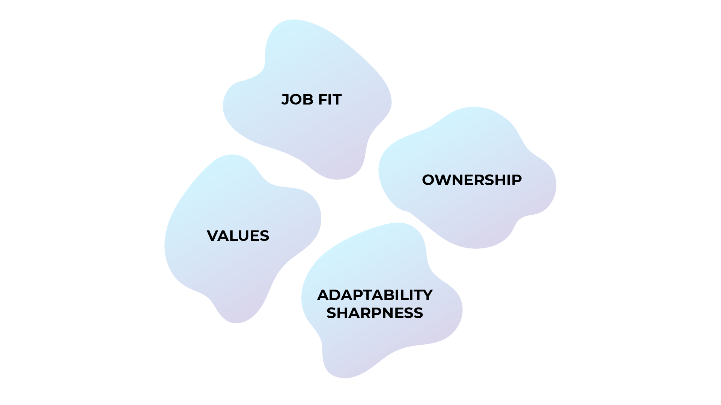

1. **The job fit:** The technical skills (hard skills) necessary to perform the job.

2. **Values:** Algolia has five values. During the recruitment process, we dedicate one full day to evaluating them.

* Care
* Trust
* Candor
* Humility
* Grit

3. **Ownership.**

4. **Adaptability, sharpness.**

***How do you assess soft skills?***

To assess soft skills, we may ask **behavioral questions** about **situations** that the candidate has **experienced.**

Behavioral questions are based on real-life situations, while situational questions are based on hypothetical, "How would you react if ..." situations.

Here are some examples of behavioral questions asked in the interviews at **Algolia.**

Try to play along and prepare for these questions!

* "Tell me about a time when you had to delegate your work to a colleague or classmate: How did you prepare for it? How did you feel about entrusting your work to someone?" These questions assess your ability to **trust** others, plan, and **organize** yourself.
* "Tell me about a loved one or coworker who has a skill that you don't have. How would you use this skill if you had it?" This question assesses **humility** and the ability to recognize strengths in others.

The best way to prepare for an interview is to identify concrete, real-life examples in which you've used your soft skills.

**Algolia** isn't the only company that has noticed the value of soft skills in their recruits. More companies are putting a focus on assessing soft skills in their recruitment process. We interviewed **Fabiana Giorgi**, from **Gartner TalentNueron**, to get another perspective on the role soft skills play in the recruitment process.

#### **Let's Recap!**

In this chapter, you discovered that:

* Recruiters value **soft skills more and more.**
* You can improve the soft skills you already have by identifying **concrete situations** in which you've used them.

*By now, you understand the relevance of soft skills in the work world. However, it's still important to keep hard skills in mind. You'll see why in the next chapter.*

## ***1.5.Identify Key Differences Between Hard and Soft Skills***

##### **Dispel the Popular Beliefs About Soft Skills**

**❌ Soft skills are only part of personal development.**

Yes, they allow you to grow personally, but they also impact your **relationship with others.** For example, if you build your self-confidence, your loved ones will feel confident when they are with you.

**❌ Soft skills are "soft" skills.**

"Soft" isn't a very accurate description of these abilities; it's more accurate to call them transversal or behavioral skills.

Soft and hard skills complement each other. For example, soft skills are just as necessary to top athletes as technical skills. They need to concentrate and manage their emotions to prepare for games or matches.

**❌ Soft skills are not available to everyone.**

Some believe that your abilities are innate, and you have to live with those you were dealt with. For example, someone who has never really done a creative activity might think they're not creative.

Soft skills are **skills,** and you have the power to **act on them** by creating experiences that allow you to develop them. It's about changing the plasticity of your brain through experiences.

Brain plasticity is the ability to reshape your brain's connections, depending on your environment and experiences.

Anyone can develop creativity and build soft skills if they have the means.

#### **It's Your Turn**



Choose **three people who you think are successful.** They could be family members, former colleagues, classmates, or public figures.

Identify **the soft skills** they have that allow them to succeed.

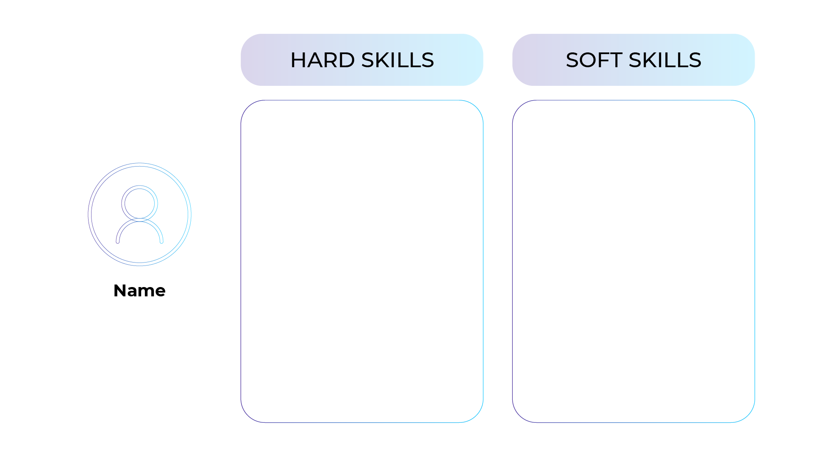Complete this table with soft and hard skills.

Take a few minutes complete your list on a piece of paper or in your journal.

Here's an example using the professional tennis player, **Roger Federer.**

**Hard Skills**

* Over the years, Federer has developed unmatched **technical** expertise.
* He invented several technical tennis shots, such as the **drop shot.**
* Federer has one of the most beautiful **one-handed backhands** in tennis.
* He is very **precise** and **fast** on the court.

**Soft Skills**

* He can **manage his emotions** in complex situations.
* He can **concentrate** intensely for several hours.
* Federer has precise power of **observation,** especially when adapting his opponent.
* He can **anticipate** (cultivated through observation).
* Federer has **self-confidence** (from years of experience).
* He is **creative,** which isessential for certain shots.

As you can see, his technical and behavioral skills are complementary.

#### **Let's Recap!**

In this chapter, you learned that:

* Soft skills and hard skills are **complementary.** Soft skills are almost always needed to use hard skills.
* **Anyone** can develop their soft skills.

*In this first part of the course, you learned that a computer or robot could not perform soft skills, unlike hard skills. These human skills allow us to improve our world for everyone's benefit.*

*In the next chapter, you'll identify your soft skills!*

* [#](https://openclassrooms.com/en/courses/6951366-develop-your-soft-skills/7016056-identify-key-differences-between-hard-and-soft-skills#/id/r-7033574)

# **Quiz**

# **1.6.Why Are Soft Skills Essential?**

### **Evaluated skills**

* Identify why soft skills are essential.

### **Description**

Your friend Cindy wants to learn more about the course you are currently taking: "Develop Your Soft Skills." Cindy is 26 years old and has just completed a training course to become a developer. Help her to better understand how soft skills could help her build her professional career.

* **Question 1  
  You tell Cindy about the course you are taking. Her first reaction is, "It sounds interesting, but what does "soft skills" actually mean?" Choose the definitions and translations that you think are correct.** They are behavioral skills.
  + They are transversal competencies.

*Soft skills are profoundly human skills that can be developed throughout one's life and are useful for all professions. Contrary to popular belief, soft skills are genuine competencies that complement hard skills (or technical skills)!*

* **Question 2  
  “OK, could you give me some examples?" Select examples of soft skills from the following suggestions.**Creativity
  + Critical thinking
  + Collaboration
* *You can develop your soft skills to deliver concrete and objective results. If I train my mood, I'm not sure I'm going to please everyone. Similarly, how could you measure something, such as kindness? (some might even abuse it). On the other hand, I will objectively generate more ideas by training my creativity. Similarly, by developing my critical mind, I will be able to own my point of view and convey it to others.*
* **Question 3  
  "I've always been told that I'm not creative. It's innate, either you're creative or you're not." Is that true?***.*
  + Anyone can develop their creativity, you too!

*Like all other soft skills, creativity is accessible to all! Anyone can develop their creativity if they give themselves the means to do so. Very concrete creative techniques exist and are within everyone's reach.*

* **Question 4  
  Cindy asks you what soft skills are for and why they should be developed. How do you answer?**
  + Soft skills allow us to adapt to the changes occurring in the professional world.
  + Soft skills allow us to improve our relationships with others, to exchange and work with others.
  + Soft skills allow us to evolve with serenity and confidence.

*Soft skills allow us to evolve in an ever-changing and transforming work world. They are vital to becoming agents of change, rather than being subjected to it. Because of their interpersonal dimension, they serve the collective interest rather than individual interest.*

* **Question 5  
  Cindy reacts: "What do you mean when you say there are changes in the professional world? What are the major trends?"**
  + Machines are gradually performing technical tasks: our technical skills are less and less valuable.
  + The tools and practices are evolving faster and faster: you have to know how to adapt quickly.
  + There are increasingly complex economic, social, and environmental challenges to solve.

*Soft skills allow us to face several challenges: artificial intelligence and the automation of tasks that make our technical skills obsolete, the acceleration of time, massive digitalization, the complexity of the problems to be solved, etc. They also allow us to adapt constantly. Career paths are less and less linear, and it will be increasingly rare to pursue your entire career in the same position. Companies are looking for people who will know how to adapt to changes in their profession and their sector.*

* **Question 6  
  Cindy says, "I've just graduated from a training program to become a developer. It's a job with a promising future. I'm sure that my technical skills will still be valuable in several years and that I won't have to change my job anymore." You answer that all professions are likely to evolve. To support your point, you use the following figures:**
  + Did you know that there's an 85% chance that the profession you'll be working in 2030 doesn't exist yet?
* *A study conducted by Dell and the Institute of the Future concluded that 85% of the jobs of 2030 are unknown. Whether these forecasts are accurate or not, they invite us to reinvent our relationship to work and the future.*
* **Question 7  
  Cindy is preparing for a job interview. She asks you a question: "What do you think is more important for recruiters today: soft skills or hard skills?" How do you answer?**
  + Soft skills are as important as hard skills.

*Soft skills and hard skills are complementary. Generally speaking, both facets are equally important. According to a study by Robert Half in 2016, 52% of the human resources managers surveyed gave at least as much importance to soft skills as to hard skills.*

* **Question 8  
  Cindy has another question for you: "Knowing that I have little work experience, what do you think is one of the best ways to prepare myself and my soft skills for job interviews?"**
  + The best way is to prepare yourself for behavioral questions is to identify situations you have experienced in which you have used soft skills.

*These two types of questions allow you to prepare. However, behavioral questions are more concrete and applied: they prove that you have succeeded in mobilizing your soft skills in a previous situation.*

## ***2.1. Become Aware of Your Skills***

*In this part, you'll explore and develop your own soft skills. To get started, examine the abilities that you already have.*

#### ***Identify the Three Main Categories of Soft Skills***

1. ***Adaptability*** *allows you to approach changes and developments calmly. This category includes the ability to organize, learn, and practice emotional intelligence.*
2. ***Social skills*** *let you interact and work fluidly with others. They include communication, collaboration, and service orientation.*
3. ***Problem-solving*** *allows you to face societal and work challenges. Critical thinking, creativity, and decision-making are the key soft skills.*

#### ***Learn From Your Past***

*One of the best ways to develop your soft skills is to evaluate where you* ***currently stand*** *with them. It lets you recognize the ones that are already well-developed, and those you want to improve.*

*To become aware of your soft skills, consider a past* ***situation;*** *for example:*

* *Looking for a job (or a work-study program, an internship).*
* *Selecting a training course.*
* *Switching to another profession.*
* *Preparing for an interview.*
* *Or another situation.*

*Do you have something in mind?*

*Let's say you've thought about preparing for a job interview.*

*What do you think you'll need to succeed?*

*Take a few minutes to think about it, and list some examples.*

*Of course, there's not just one possible set of answers. (There are certain factors beyond your control that could determine if you get the position.) Perhaps you highlighted* ***behavioral aspects*** *among your answers. Is there a way to demonstrate these to the recruiter? Maybe you can improve them before the interview. Some can include the ability to* ***communicate*** *well. For example, how to explain that time you changed job. Another could be managing* ***your emotions*** *if a question confuses you, or showing that you're* ***creative*** *by distinguishing yourself from the other candidates who have the same hard skills.*

*You are aware of some soft skills you feel confident in, but do you know the ones you can improve?*

#### ***Rate Your Skills***

*You may already have several soft skills at different stages of development.*

*Find out where you stand by rating yourself on the OpenClassrooms benchmark skills below using a scale of 0 to 10:*

* ***Grade 0*** *= you feel unable to use this skill.*
* ***Grade 10*** *= you feel very comfortable using this skill.*

*Copy the diagram below in a notebook or digital journal.*

*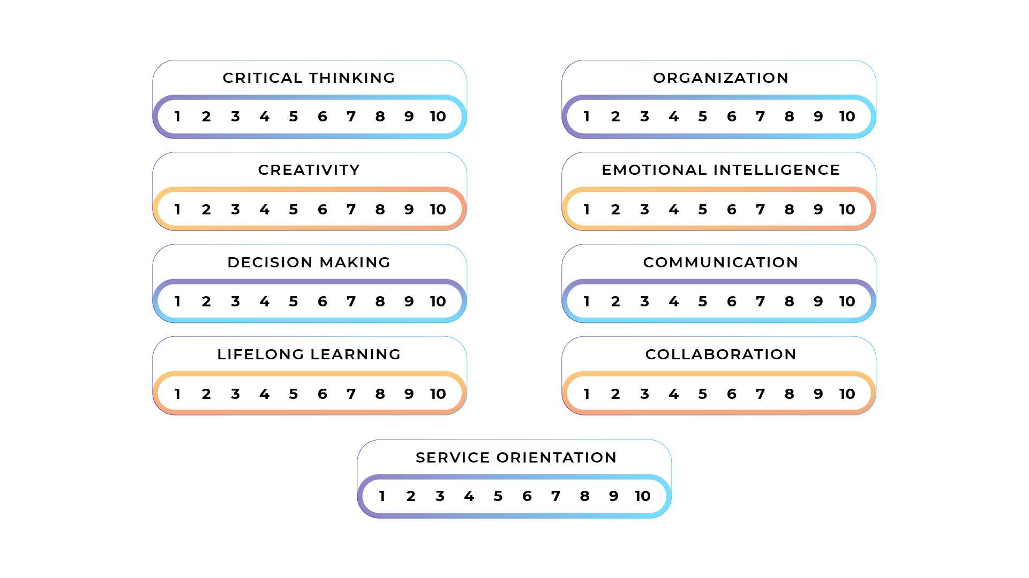Self-assessment grid*

#### ***Identify Your Areas for Improvement***

*After completing the self-assessment, you should have identified the soft skills that could use some improvement.*

*Let's take it one step further. Think back to situations in which you thought you failed. Do you have them in mind?*

*Now answer the following question: if you had to relive these situations, what soft skills would you use to get a different result?*

*Write down your answer. It will be useful in Part 3 of this course.*

*When you face work or personal challenges, write down the soft skills that helped you (if it was a success), and the ones that could have helped you (if it was a challenge). This way, you'll learn more quickly from your experiences. It's a good idea to keep a journal with you.*

#### ***Gather the Opinions of Those Around You***

*To go one step further,* ***ask those in your circle to help you*** *think about other soft skills you might have missed. For instance, ask them if they think you manage your emotions, make decisions, or organize yourself well. Could some of those soft skills have been* ***useful*** *in the situations you wrote about?* ***Listening*** *to how others see you is an excellent way to build your abilities. Choose people you trust!*

#### ***Let's Recap!***

*It's necessary to* ***step back*** *from the situations you're going through to develop your soft skills. To do this, you can:*

* ***Write*** *down what soft skills you used and what ones you could have used more after each successful or challenging event.*
* ***Assess*** *yourself on the following nine soft skills: creativity, critical thinking, decision-making, communication, collaboration, service orientation, lifelong learning, organization, and emotional intelligence. Go back and use the 0 to 10 ratings you did earlier in the chapter.*
* ***Consult those around you*** *to get an outside perspective.*

*In the following chapters, you'll explore concrete techniques to develop your soft skills: adaptability, interpersonal skills, and complex problems-solving. Let's start with adaptability.*

## ***2.2. Develop Your Ability to Adapt***

*How do you adjust to a continually changing world? In this chapter, you'll learn how to explore your capacity to adapt, which is necessary to face any changes.*

#### ***Adaptability in the Professional World***

***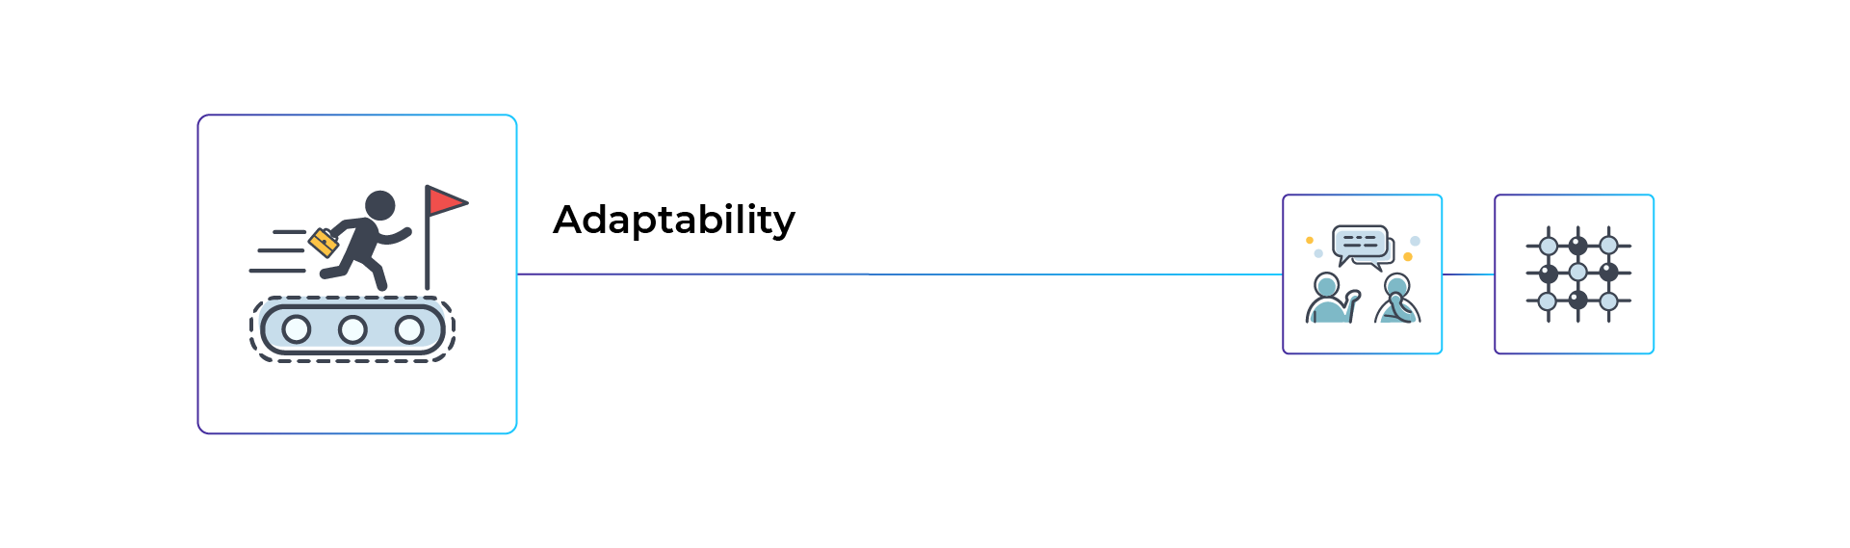****What can you do to adapt to the rapid changes in business? What skills can you use?*

*What can you do to adapt to the rapid changes in business? What skills can you use?*

##### ***Lifelong Learning***

**

*Lifelong learning is the ability to create learning opportunities to help you adapt to changes at work and society.*

*Learning to learn, in particular, means:*

* *Learning independently.*
* *Learning from interactions with others and helping others learn by sharing skills and practices.*
* *Demonstrating introspection and reflexivity.*
* *Showing curiosity and being inspired by new ideas and methods.*
* *Knowing how to concentrate.*

*Want to find out more? Take the courses* [***Learning to Learn***](https://openclassrooms.com/fr/courses/5281811-learn-how-to-learn) *and* [***Working Independently***](https://openclassrooms.com/fr/courses/5291566-learn-to-work-autonomously) *offered by OpenClassrooms.*

##### ***Organization***



*Organization is the ability to organize work and assume responsibilities in a changing environment.*

*Knowing how to organize means:*

* *Knowing how to define objectives.*
* *Managing time effectively.*
* *Being proactive, reacting quickly when necessary.*
* *Showing discipline.*
* *Working independently.*
* *Taking the initiative and assuming responsibilities.*

*Want to find out more? Go to the course:* [***Managing Your Time Efficiently***](https://openclassrooms.com/fr/courses/5944991-gerez-votre-temps-efficacement) *offered by OpenClassrooms.*

##### ***Emotional Intelligence***



*Emotional intelligence is the ability to identify your emotions and know how to manage them. It's also the capacity to identify and adapt to others' feelings.*

*Emotional intelligence refers to:*

* *Demonstrating resilience and adapting to changes.*
* *Managing stress.*
* *Knowing how to motivate yourself and others.*
* *Demonstrating the ability to anticipate.*

*"Emotion" comes from the Latin word, emovere, which means to set in motion. You are "set in motion," depending on the emotions that move through you.*

*To get started, be aware of one thing:* ***your thoughts create your emotions.*** *And you have the power to guide your thoughts.*

*For instance, if you're preparing for a job interview and find yourself thinking about a previous interview that went wrong, chances are you're negative. But if you become aware of the unpleasant thought, you can* ***direct your mind*** *to another* ***more positive one.*** *To do this, remember back to an interview that went well, and you got the job or gig.*

*As Daniel Goleman, the American psychologist, noted, "the emotional flow in which we are immersed is exactly similar to the flow of thoughts that pass through our mind."*

***If your thoughts are pleasant, your emotions will be too.*** *And vice versa.*

##### ***It's Your Turn***



##### ***Exercise: Learn From Your Past***

*Think back to your past experiences: when was the last time you faced a* ***significant change?*** *Did you have to* ***adapt*** *to it? Which* ***skills*** *were you able to develop? Which ones should you have developed?*

*The questions below may give you some inspiration:*

* *How well were you able to manage your* ***emotions*** *and create positive energy in this new environment?*
* *How well did you get* ***organized,*** *define your goals, and manage your time?*
* *How well were you able to grasp the* ***learning opportunities?***

*As always, remember to write down your answers. You'll build your skills by taking the time to observe them and your behaviors!*

##### ***Challenge: Change Your Bad Habits***

*They say it takes* ***21 days*** *on average to adopt a new habit. Change is never fun, but you can learn to embrace it.*

*For this activity, choose a* ***daily habit*** *that gets in your way. It should be one that you're willing to let go of. Some examples could be how often your clean, your Sunday night bedtime, how often you eat prepared meals, or even the amount of time you spend on your cell phone. Screen time is a big issue for some. According to the magazine Socialize, the French spent an average of 162 minutes per day on their phones in 2016!*

*Once you've chosen your habit, define your* ***goal.*** *Do you want to* ***remove*** *it altogether,* ***change******it,*** *or* ***replace*** *it with another?*

*Get ready to devote at least* ***three weeks*** *to it. At the end of these three weeks, try to become aware of your ability to adapt.*

*Write down your goal and the results after three weeks.*

#### ***Let's Recap!***

* *In a constantly changing world, it's essential to learn how to adapt.*
* *The soft skills that make it possible to face changes include* ***lifelong learning,******getting organized,*** *and* ***emotional intelligence.***
* *It's possible to develop these skills and train yourself by setting* ***new challenges,*** *such as changing a habit within a limited time.  
     
  In the next chapter, let's explore a new range of skills: interpersonal or social skills that allow you to work effectively with others.*

## **2.3. Develop Your Social Skills**

In this chapter, you'll learn more about interpersonal skills, which allow you to work and interact peacefully with others. And you'll see, these are vital skills.

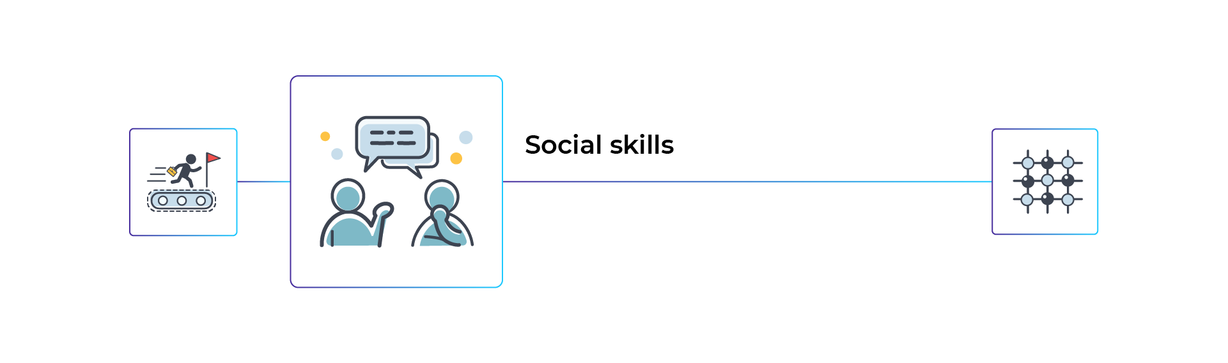

#### **Our Brain Is Neurosocial**

What does that mean?

American psychologist Daniel Goleman who has worked extensively with **emotional intelligence,** popularized the term neurosocial.It refers to two broad, simple principles about our interactions: we need other people and are emotionally connected to others.

##### **We Need Each Other**

We need others to express ourselves and unlock our potential.

For example, how could you know that you need to develop your oral fluency if you don't have a **benchmark?** Thanks to others, you can adjust **your attitude in real-time using your soft skills.**

Suppose you are in the middle of a discussion and observe that the person you're speaking to doesn't understand you. In that case, you'll have to change your approach and communicate your ideas more clearly.

##### **We Are Emotionally Connected to Others**

We are emotionally connected to others through our **mirror neurons,** which allow us to copy what we observe. These neurons use **mimicry** and **empathy.**

Mirror neurons are activated when you observe others' actions and attitudes. Daniel Goleman explains that it's almost like we are **connected to others by WiFi.**

For example, when you see happy people around you, you're likely to be happy as well. If someone gets angry with you, you'll probably get angry too.

Once again, emotions help you understand your relationships with others. If you learn how to decipher them, you can avoid taking on others' feelings or attitudes.

This skill, **emotional intelligence,** is now one of the most in-demand in the job market and directly impacts how you work with others.

#### **Social Skills in the Professional World**

There are three key social skills: communication, collaboration, and service orientation. Let's go more into detail.

##### **Communication**



Communication is the ability to convey information verbally, non-verbally, visually, or written and adapting to the target audience, whether it's one or more people.

Communication is crucial for all professions: more and more people who previously did not have to interact must now learn this skill. For example, many developers now have to work with different teams to automate specific tasks. They must express their ability, where they are in the process, and their goals while understanding what others convey to them. Communication skills mainly cover the following aspects.

* **Multimedia communication:** choosing the most suitable media and format to convey a message.
* **Oral communication:** presenting an idea, opinion, or analysis, whether in front of one person or a group.
* **Written communication:** adhering to the writing rules suitable to the medium, audience, and context.
* **Visual communication:** diagramming, illustrating, or visualizing complex information.

To develop your ability to communicate, consider taking the [**Speak in Public**](https://openclassrooms.com/fr/courses/5253451-speak-in-public), [**Improve Your Presentation Skills**](https://openclassrooms.com/fr/courses/5948166-improve-your-presentation-skills-1) classes.

##### **Collaboration**



Collaboration is the capacity to bring several individuals together to work towards a common goal.

The ability to collaborate with others is a vital soft skill in the rapidly changing workplace. It ensures that work progresses collectively. Consider a band: several musicians play different instruments, yet their collaboration produces a coherent (and hopefully pleasant) melody. The same goes for workers at a company, who must collectively create a product.

Collaboration mainly refers to the following dimensions:

* **Teamwork.**
* Facilitating **collective intelligence:** knowing how to lead a working group and producing collaborative creations.
* **Conflict resolution.**
* Receiving and sharing **constructive feedback.**
* **Empathy:** actively listening to the messages, feelings, and emotions of the person you communicate with and adapting to them.

Want to go further? Take the [**Resolve Conflicts at Work**](https://openclassrooms.com/fr/courses/2348776-resolve-conflicts-at-work) and [**Work Effectively as a Team**](https://openclassrooms.com/fr/courses/5164326-learn-teamwork) courses at OpenClassrooms.

##### **Service Orientation**



Service orientation is the ability to use empathy and listening skills to meet others' needs.

In a service economy, the ability to identify others' needs correctly is critical, and consumers today want quality customer service. The service-oriented soft skill is incredibly helpful with after-sales service.

Service orientation consists of:

* Knowing how to respond to a user or customer needs appropriately.
* Knowing how to resolve **conflicts.**
* Knowing how to give and receive **constructive feedback.**

Now let's take a look at a real world example of these social skills in the workplace. We spoke with **Anna Thorsdottir,** a specialist in creative influencer marketing and content branding, to better understand how these three key social skills have made her a better leader.

#### **It's Your Turn**



##### **Exercise: Learn From Your Past**

Think back to your **most recent experiences:** when did you have difficulty in a work or school relationship? How could you have overcome this dilemma?

If you listen, are patient, manage your emotions, and practice empathy, you can **change your attitude** and the situation.

When you practice soft skills, you adjust your attitude toward others by putting your intentions into words.

For example, "The next time I talk to this person, I want to listen more." If I set this intention, I'll improve our discussion's quality by paying better attention to the other person's perspective.

Through mirror neurons, a change in attitude can impact you in two ways: it alters how you experience the situation and can also influence how the other party experiences it.

##### **Challenge: Develop Your Network**

Professional life often works through networks.

At least 70% of people find jobs through their network, and not from posted job vacancies. It's called the "hidden job market."

You can expand your network by identifying **three people** in your professional social circle who you would like to contact. You could be interested in their business sector, job skills, experience, philanthropy, etc. Plan a telephone **interview** (or an in-person meeting) of at least 30 minutes to get to know each of them and perhaps consider future discussions or collaborations. It's also called an information-gathering interview. This exercise may not feel natural, but it's essential to your learning process.

#### **Let's Recap!**

In this chapter, you discovered that:

* Our brains are **neurosocial.** We are all emotionally connected.
* The three key social skills in demand in the professional world are **communication,** **collaboration,** and **service orientation.**
* You can develop your social skills by **expanding your professional network.**

*And while skills can solve many relationship problems, they also help solve other more complex issues. Let's explore this in the next chapter.*

## **2.4. Develop Your Ability to Solve Problems**

How can you develop your ability to solve problems in this increasingly uncertain and complex world? Let's find out in this chapter. 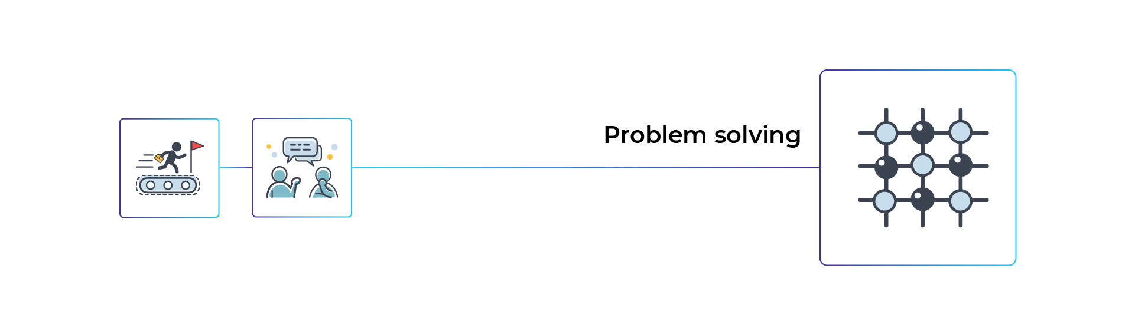

#### **Start With a Puzzle**

To explore this problem-solving soft skill, try solving this small puzzle. The purpose is to make you aware of the **need to get out of the box** or, in other words, to gain a perspective that will help you solve complex problems.

##### **The First Part of the Puzzle**

Copy the figure below, then try to **connect the nine circles** by tracing **four straight lines in a row without lifting the pen** off your sheet. Each of the circles must be crossed by at least one straight line.



Not that easy; is it?

##### **Solution**

You had to leave the "suggested" framework (the one limited by the nine circles) to solve it.

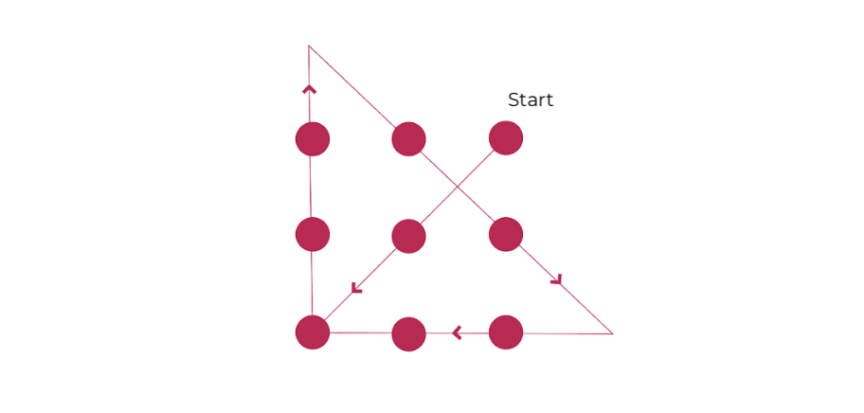

##### **The Second Part of the Puzzle**

Here's the second part of the puzzle. It's less well known.

On the back of your sheet, copy this same diagram:

Figure - Square

Now make sure that **each of the circles** is **crossed by at least one straight line,** but this time, only draw **three consecutive lines** **without lifting the pen.**

Did you try it? Check your answer!

##### **Solution**

We didn't specify the size of the small circles or their spacing in the instructions. You may have drawn the figure according to the previous nine small circle framework. It's also likely that your brain translated "little circles" as "small dots," making it impossible to solve this second part of the puzzle. Here's the solution:

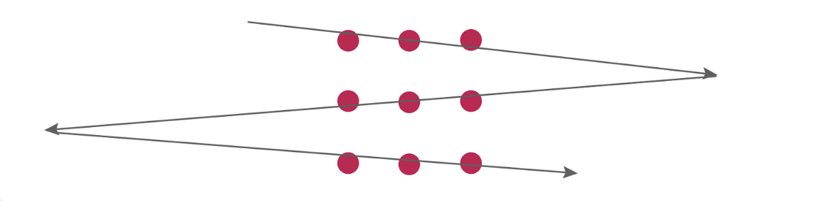Figure - Solution

Again, the key to solving the problem was to **broaden its framework.**

#### **Explore Analytical and Intuitive Thinking**

Have you ever noticed that sometimes you find solutions to your problems when you least expect them? It's normal.

To solve a problem using only the analytical part of your brain isn't enough.

According to **Daniel Kahneman,** the Nobel-Prize winning psychologist, and economist, our **thoughts** have **two speeds:**

* **Analytical thinking** can quickly get tired when trying to solve a problem. It's called a **slow** thought (like a computer that grinds along before providing a result).
* **Intuitive thinking** can solve a problem at any moment, for example, by paying attention to the issue at hand. It's called a **quick** thought.

The two speeds of thought are **complementary.** Solving a problem requires thinking and changing your point of view.

#### **Problem-Solving in the Professional World**

It is important to understand how our problem solving skills are applied in the professional world. After all, problem solving is at the core of improvement. In this section, we will focus on three key problem solving skills: **Critical Thinking, Creativity,** and **Decision Making.**



Critical thinking is the ability to form a point of view on a particular subject and express it in a clear, confident, and constructive manner. Don't confuse it with a negative judgment about someone or something!

Critical thinking covers the following dimensions:

* **Problematization:** formulating a question or problem to arouse reflection.
* **Processing information and data.**
* **An objective analysis** of a situation.

##### 

Creativity is the ability to generate new ideas, solutions, and approaches to solving a particular problem. It can involve thinking *outside of the box*.

Creativity mainly covers the following aspects:

* Generating ideas and imagining **possible solutions** to solve a problem.
* Taking the **initiative.**
* Demonstrating **curiosity,** exploring new perspectives.



Decision-making is the ability to make a conscious choice in a minimum of time. We make decisions all day, but many are unconscious, and sometimes we get stuck when it comes to important ones. This soft skill makes it possible to remove this doubt.

To make decisions, you need to know how to:

* Objectively analyze information.
* Process information and data.
* Anticipate the consequences of a choice.
* Be proactive.
* Take responsibility.
* Adhere to your values or the values of the organization.

#### **It's your turn**



##### **Exercise: Learn From Your Past**

Think back to a recent problem you had to solve: how did you do it? Which **skills** did you develop? Which ones should you have developed?

The questions below may inspire you:

* Have you ever taken a step back from a problem to clear your mind and thought of different ways of solving it? It engages your **critical mind.**
* Have you been able to demonstrate **creativity,** perhaps to consider new solutions to this type of problem?
* Did you know how to **make a decision** or reach a solution to the problem? If so, how did you make it?

As always, remember to record your answers in your notebook or this document. You develop your skills and behaviors by taking the time to observe them!

##### **Challenge: Develop Your Network**

**Choose a problem** that you haven't been able to solve and **talk about it** with at least one person (ideally, several) in your network. They could be the people you contacted during the previous "Develop Your Network" challenge.

The goal is to get an **outside perspective** (and, if possible, several) on your problem.

After considering others' opinions, try creating a new way of looking at your problem **(a new perspective).** If you detach and avoid judging, you should see some potential new lines of action for solutions.

#### **Let's Recap!**

In this chapter, you discovered that:

* Our brain has two speeds of thought: slow **analytical thinking** and quick, **intuitive type thinking.** These two systems are useful for solving a problem: you have to think, but you also need to take a step back.
* Three problem-solving skills are particularly in-demand in the labor market. They are **creativity,**  **critical thinking**,and **decision-making.**
* You're able to approach your problems with a **fresh and objective perspective** by asking others for their opinions.

*It's time to take action and use your soft skills to achieve your goals. You'll learn how to do this in the next part by building your own* ***action plan!***

# **Quiz**

# **2.5.Are You Able to Assess Soft Skills?**

### **Evaluated skills**

* Self-assess soft skills.

### **Description**

Your friend Cindy recently graduated as a developer. She wants to evaluate her soft skills to learn more about her strengths and weaknesses. It's up to you!

* **Question 1  
  Cindy asks you about the best techniques for self-assessment. What is your answer?***Careful, there are several correct answers.*
  + You can rely on a competency repository like the OpenClassrooms one and position yourself on the different soft skills.
  + You can start with real-life situations. For example: which soft skills helped you to resume your training?
  + You can ask for advice from those around you.
* *Self-assessment with a competency framework, 360° assessment with family and friends, or starting from real-life situations, are good techniques for positioning your soft skills.*
* **Question 2  
  Cindy used to be an orderly. After two years on the job, she decided to retrain and took online training to become a developer. What soft skills did she demonstrate by accomplishing this task?***Careful, there are several correct answers.*
  + Setting objectives
  + Reflexivity
  + Lifelong learning
  + Managing her time
* *Of course, creativity and the ability to give constructive feedback may be useful to Cindy as a developer in the future. But if you look at her career transition, the following skills have been indispensable to her:*
* *Setting objectives: Cindy had to set clear and attainable goals to transition successfully.*
* *Reflexivity: to resume a training course requires a step back from oneself.*
* *Lifelong learning: to follow a distance learning course requires autonomy and real curiosity, to learn continuously.*
* *Managing her time: retraining requires a lot of energy and a real capacity for organization to learn in the long term.*
* **Question 3  
  In her next job as a developer, in what situations will Cindy need to be exceptionally emotionally intelligent?***Careful, there are several correct answers.*
  + Comment on another developer's code.
  + Manage her stress, adapt to a new work environment.
  + Motivate her colleagues to set up new team projects.

*Emotional intelligence is directly related to the ability to adapt to change and to interact with others. It includes managing stress, but also the ability to adapt to the emotions of others. For example, if Cindy comments on someone else's code, she will need to adapt to that person and phrase her feedback so she doesn't offend the other person. Similarly, if she wants to create new projects with her team.*

* **Question 4  
  You try to explain to Cindy what emotional intelligence is and start talking about mirror neurons. What examples can you use to illustrate this notion?***Careful, there are several correct answers.*
  + If you are talking to someone and change your attitude, they will also change theirs, thanks to the mirror neurons' effect.
  + If you observe someone being hurt, your mirror neurons may become active and generate the same emotion, as if you were suffering yourself.
  + If you observe someone performing an action, you memorize it and reproduce it without even realizing it. It's the same as with children who are learning to walk.
* ***Mirror neurons put us in the best position to reflect what we observe. They help to explain the mechanisms of mimicry and empathy. They are activated when we observe the way of doing or being of one or more people. For example: when I observe joyful people around me, I will be inclined to experience joy myself.***
* **Question 5  
  Cindy starts looking at the OpenClassrooms competency repository and wonders about the collaboration soft skill. She asks you which two personal situations best illustrate her skill?***Careful, there are several correct answers.*
  + I had to resolve a conflict between colleagues in my previous job. There were regular conflicts over time off. I acted as a mediator and tried to find common ground.
  + Last year, I organized an event with three friends. My role was to contact artists who would like to participate in the event. So I solicited my entire network and asked for all my friends and family's opinion to identify artists who might be interested.
* ***Collaboration can include conflict resolution, giving and receiving feedback, working as a team, etc. Responses 3 and 4 represent these dimensions. Answer 1 places more emphasis on the spirit of competition, Answer 2 on service orientation.***
* **Question 6  
  Problem-solving is one of the key skills Cindy will need as a developer. Explain what you've learned about this, about the way our brains work. Select the true statements:***Careful, there are several correct answers.*
  + Thanks to your intuitive and fast thinking system, you can solve problems when you least expect it.
  + Your brain works at two speeds: the analytical, slow thinking system on one side, and the intuitive, fast-thinking system on the other side.
* *The distinction between the intuitive right brain and the analytical left brain is a neuromyth (Answer 1). There are two systems of thought: on the one hand, the slow, analytical system approaches problems through rational analysis; on the other hand, the fast, intuitive system approaches problems from a more intuitive and emotional angle. This second system makes solving problems possible when we least expect it.*
* **Question 7  
  Which of these behaviors show that Cindy has been able to develop and assert her critical thinking?***Careful, there are several correct answers.*
  + When it comes to changing a method or practice in her team, Cindy raises relevant and focused questions to deepen and guide thinking.
  + Before making a decision, Cindy listens and integrates different points of view to form her opinion.
* *Using critical thinking means: raising pertinent questions to orient or deepen a reflection (Answer 2). It's also collecting and sharing constructive feedback (Answer 3) as well as objectively analyzing information.*
* *Answer 1 reflects a lack of assertiveness: being critical implies knowing how to express and share your opinion while understanding others' points of view. It's not a good idea to share radical changes as soon as you arrive in the company before understanding other colleagues' opinions.*
* *Answer 4 refers more to lifelong learning.*
* **Question 8  
  Which of these behaviors prove that Cindy has been able to develop her creativity?***Careful, there are several correct answers.*
  + When solving a problem, Cindy systematically broadens her research field and explores new ways of doing things by searching the internet.
  + Cindy thinks outside of the box. She sometimes brings up amazing combinations of ideas and concepts.
  + Cindy knows how to use divergent thinking: she can imagine and generate multiple solutions to solve a problem.

*Creativity means:*

* *Being curious, being inspired by new ideas, methods, initiatives (Answer 1).*
* *Taking the initiative, daring to make new proposals (Answer 2).*
* *Ideating, generating multiple solutions using divergent thinking (Answer 3).*
* *Answer 4 refers to the decision-making skill.*

## **3.1. Define Your Goal**

In this third part of the course, you will build an action plan: one that will allow you to develop your soft skills to achieve an important objective.

To support you in this process, you can use the [**guided journal**](https://s3-eu-west-1.amazonaws.com/course.oc-static.com/courses/6951366/Guided%20journal%20-%20Part%203%20-%20Soft%20Skills.docx). Don't hesitate to download it now and complete it as you go along.

#### **Step 1 – Formulate Your Goal**

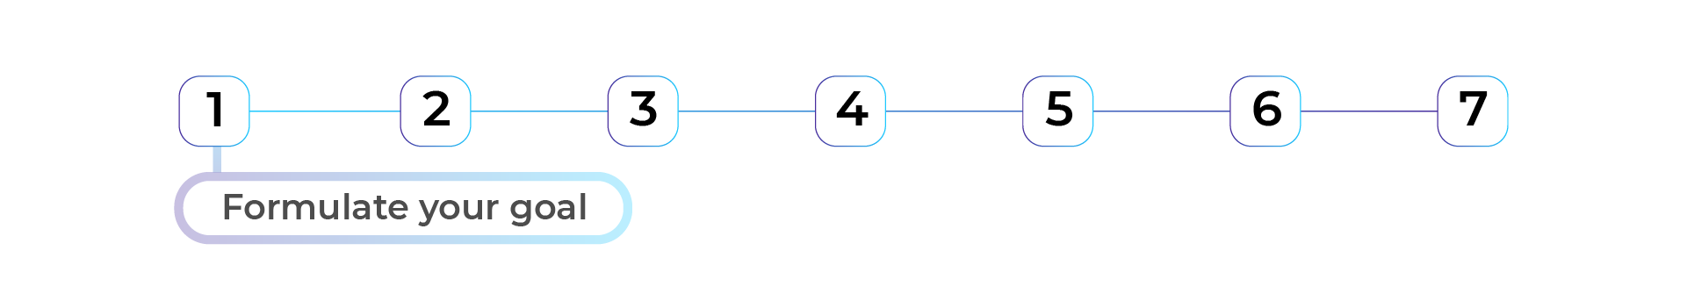

Many people don't achieve their goals because they have not articulated them enough.

This step aims to help you **formulate an important goal** and develop the soft skills to achieve it.

For example, in two months, I want to manage my time better and be more efficient on weekdays, so I don't have to work on weekends.

It's important here to work on **one goal at a time** to avoid having several soft skills within the same plan. But, of course, as all **soft skills are related to each other:** when you work on developing one (such as organization), you naturally develop others (such as discipline or concentration).

##### **It's Your Turn**



**Set your own goal, following the steps below:**

1) Identify a desire, project, dream, or goal that is close to your heart.

2) Choose which soft skill you can develop to achieve this goal.

Remember the nine soft skills: critical thinking, creativity, decision-making, communication, collaboration, service orientation, emotional intelligence, organization, and learning capacity. Which of these skills can help you achieve your goal?

3) State your goal clearly and precisely, including the soft skill that can help you achieve it.

To formulate your goal, use the SMART criteria: it must be specific, measurable, ambitious, realistic, and time-bound.

Here's an example:

"I want to learn Spanish" is not a SMART goal because I haven't defined what "learn Spanish" really means. I would need to specify the level that I want to reach and the time frame.

"I want to participate in a conversation with Spaniards without difficulty within a year and a half" is a SMART goal. It includes a deadline and a requirement level.

#### **Step 2 – Check the Sincerity of Your Statement**

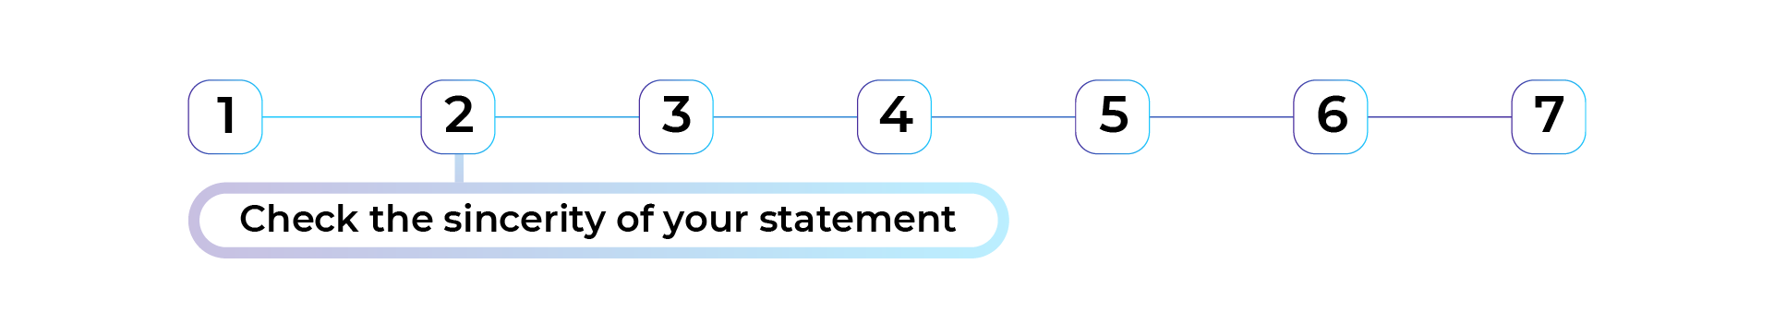

This step verifies that you are genuinely **ready to get started on your goal.**

It requires **making a contract with yourself** to confirm the following idea: "I'm not lying to myself when I set this goal."

The validation ensures that the goal comes from you, not just from external demand and that **you want to work on this improvement right now.** It's essential that the objective **makes sense and motivates you.**

In this step, you can **make the objective more or less ambitious.** For example, you might want to reduce or increase the deadlines you have set for yourself or set a higher or lower requirement.

##### **It's Your Turn**



Do you feel ready to make a real leap to achieve your goal?

If the answer is "Yes," **write a mini-contract with yourself.**

For example: "Starting today, I'm going to improve my organizational skills over the next six months. I am not lying to myself, and I'm sincere in this goal."

This type of contract may seem trivial, but it allows your brain to **set an intention** that will keep you more committed and effective.

**Keep this mini-contract visible** (on a sticky note, for example).

#### **Let's Recap!**

In this chapter, you started to build your action plan to develop your soft skills by following these two steps:

* Define a **SMART goal** **(specific,** **measurable, ambitious, realistic,** and **time-bound).**
* Create a contract with yourself to make sure you're **sincere.**

*Now let's get started on this skill-building.*

## ***3.2. Start Building Your Skills***

#### ***Step 3 – Visualize Your Skill Development***

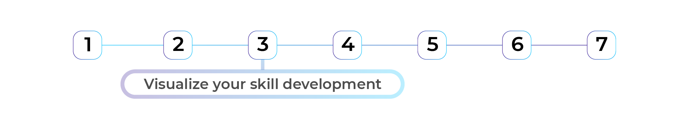

*The brain does not distinguish between* ***what it plans mentally*** *and* ***what it experiences.*** *When you visualize an action, the activated neural areas are the ones that would be activated if you actually performed the action. Therefore,* ***visualizing*** *an action* ***prepares the brain*** *to achieve it, and increases the chances of completing it.*

*Did you know that visualization is a technique used by many cutting-edge disciplines such as high-level sports or the Air Force?*

*For example, if you love to cook, what do you do before diving into a recipe? You visualize:*

* *The ingredients and utensils that you'll use.*
* *The time needed to make your meal.*
* *How your dish will look.*

*If you don't perform this visualization, your recipe is not a guaranteed success.*

*Well, the same goes for your goal of developing soft skills.*

##### ***It's Your Turn***

**

***Visualize your skill-building*** *by answering the following question: What thoughts come to mind when you think about your goal?*

*Sit in a* ***quiet place,*** *take a few moments to* ***breathe,*** *and then* ***imagine yourself achieving your goal.*** *What thoughts come to mind? Write them down on paper or in your journal.*

*For this step, I suggest using the* ***mind mapping technique.*** *Put your* ***goal*** *at your map's center, then make branches that attach to* ***the thoughts you have*** *when you think about this goal.*

*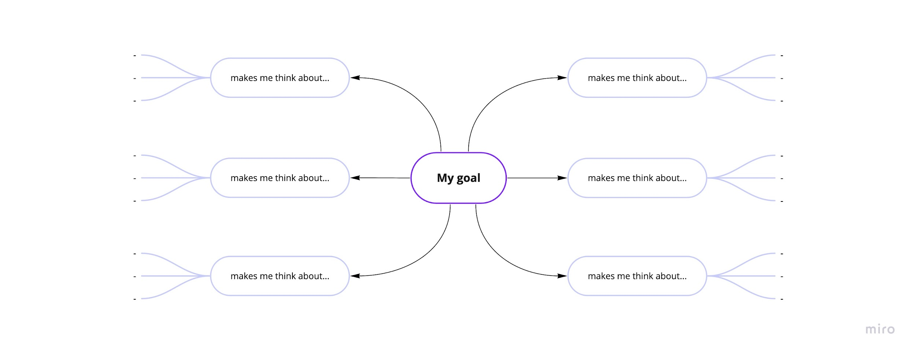Mind map*

*Here's an example of a mind map of the goal "In two months, I want to manage my time better and be more efficient during the weekdays, so I don't have to work on the weekends."*

*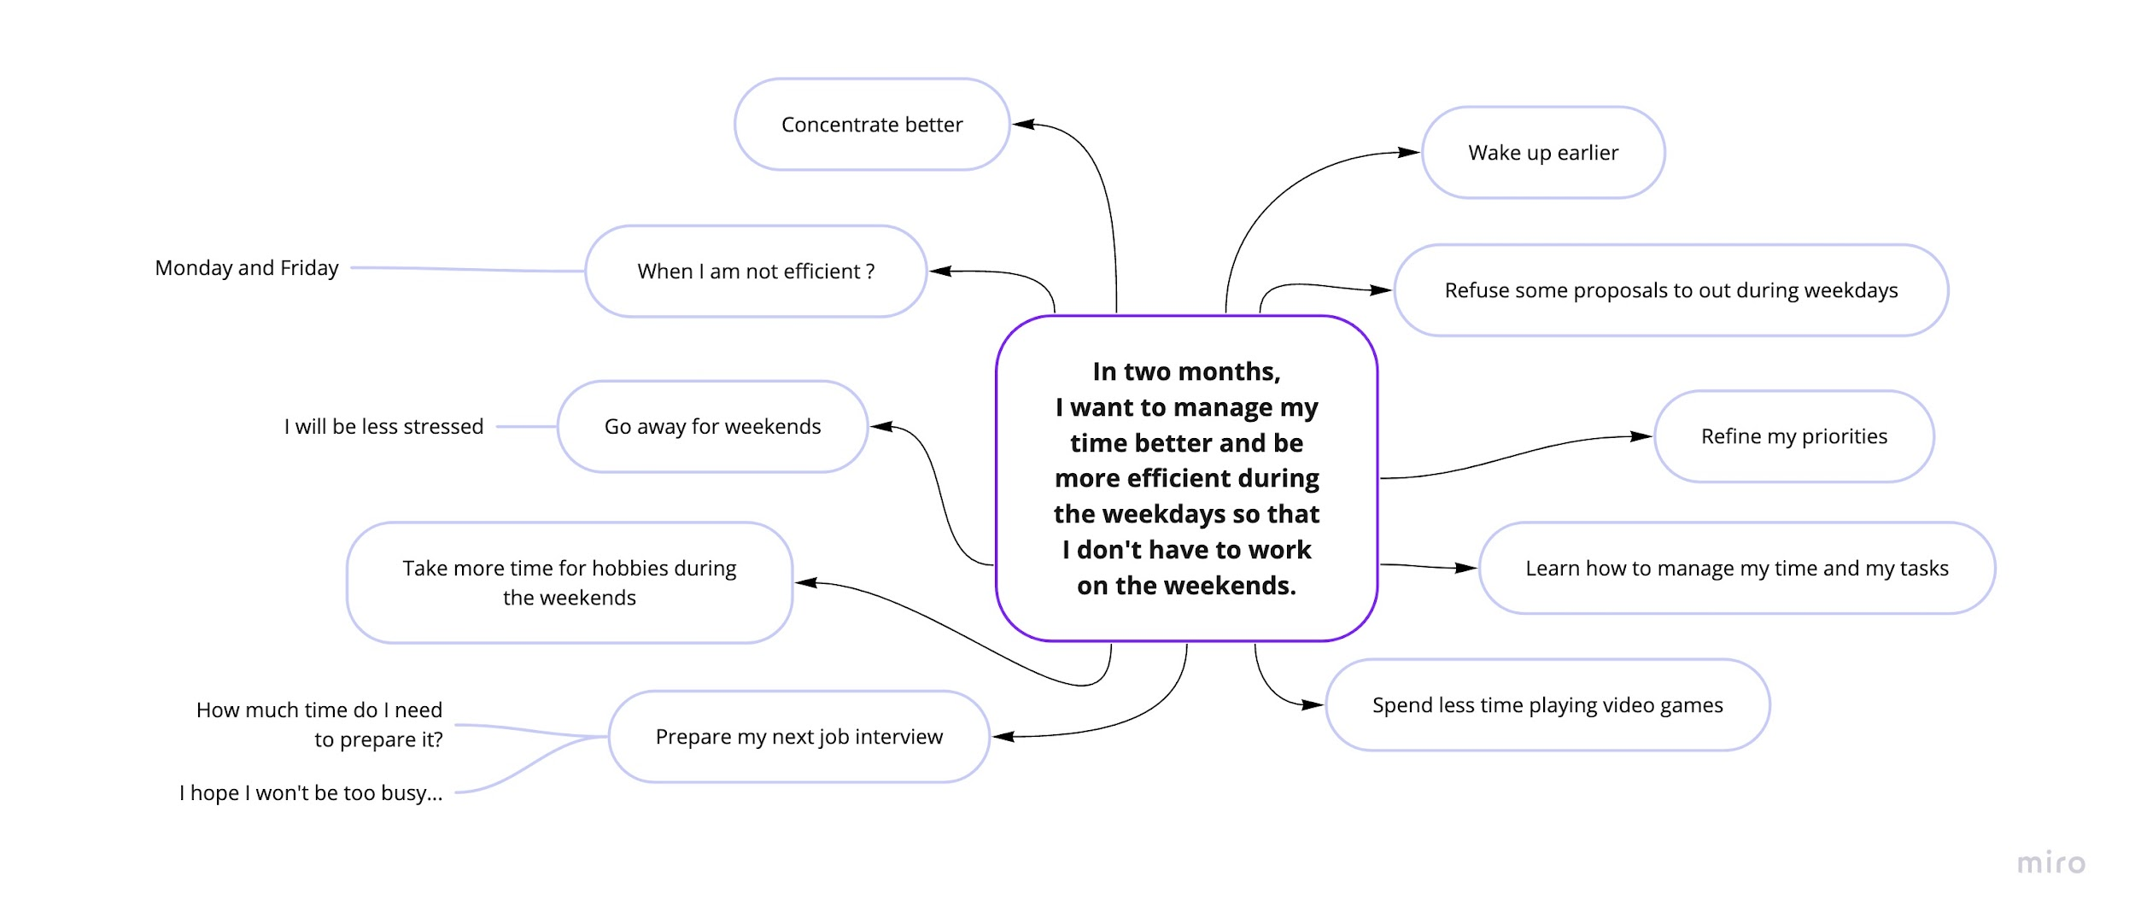Mind map - example*

*Many tools can help you create your mind map—for example, the* [***XMind***](https://www.xmind.net/) *software.*

#### ***Step 4 – Identify Your Levers and Brakes***

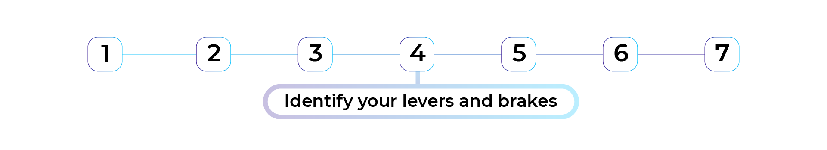

*Remember that* ***your thoughts feed your emotions,*** *and* ***your emotions feed your actions.***

*You have the power to change your thoughts. Your* ***emotional weather******forecast*** *is going to be instrumental in how you take action and reach your goals.*

*It is no accident that top athletes have learned to control their emotions. They understand that it improves their performance, especially in channeling their energy and concentration.*

*Each of the thoughts you've registered on your mind map can give you* ***pleasant or unpleasant emotions.*** *In the language of top athletes, there are* ***parasitic thoughts*** *and* ***counter thoughts.***

***Parasitic thoughts*** *refer to all the thoughts that slow you down, cause you stress, give you an unpleasant feeling, and make you uncomfortable. For example, these could be thoughts like, "I can't do it," "What will others think?" "They might judge me," "I suck," or "I'm not good enough."*

*But here's the good news: you can erase those parasitic thoughts by forming* ***counter thoughts.***

***Counter thoughts*** *direct your mind toward an optimistic perspective that will help you move forward. Some of these thoughts could include, "Whatever happens, I'm going to do my best," "I don't care what others think of me," "I've already achieved similar goals, and I can do it again," or "I'll train every day, step out of my comfort zone, and gain confidence and experience."*

#### ***It's Your Turn***

**

*Look at your mind map and try to capture the* ***emotions*** *your thoughts bring up.*

*What thoughts evoke* ***unpleasant emotions?*** *Write them down, preceded by a minus sign "-."*

*What thoughts give you* ***pleasant emotions?*** *Write them down, preceded by a plus sign "+."*

*Note thoughts that give you fluctuating emotions with "+/-."*

*Put extra plus signs in front of the more pleasant thoughts. The same goes for unpleasant emotions (minus signs).*

*I'll give you an example with my mind mapping on time management:*

*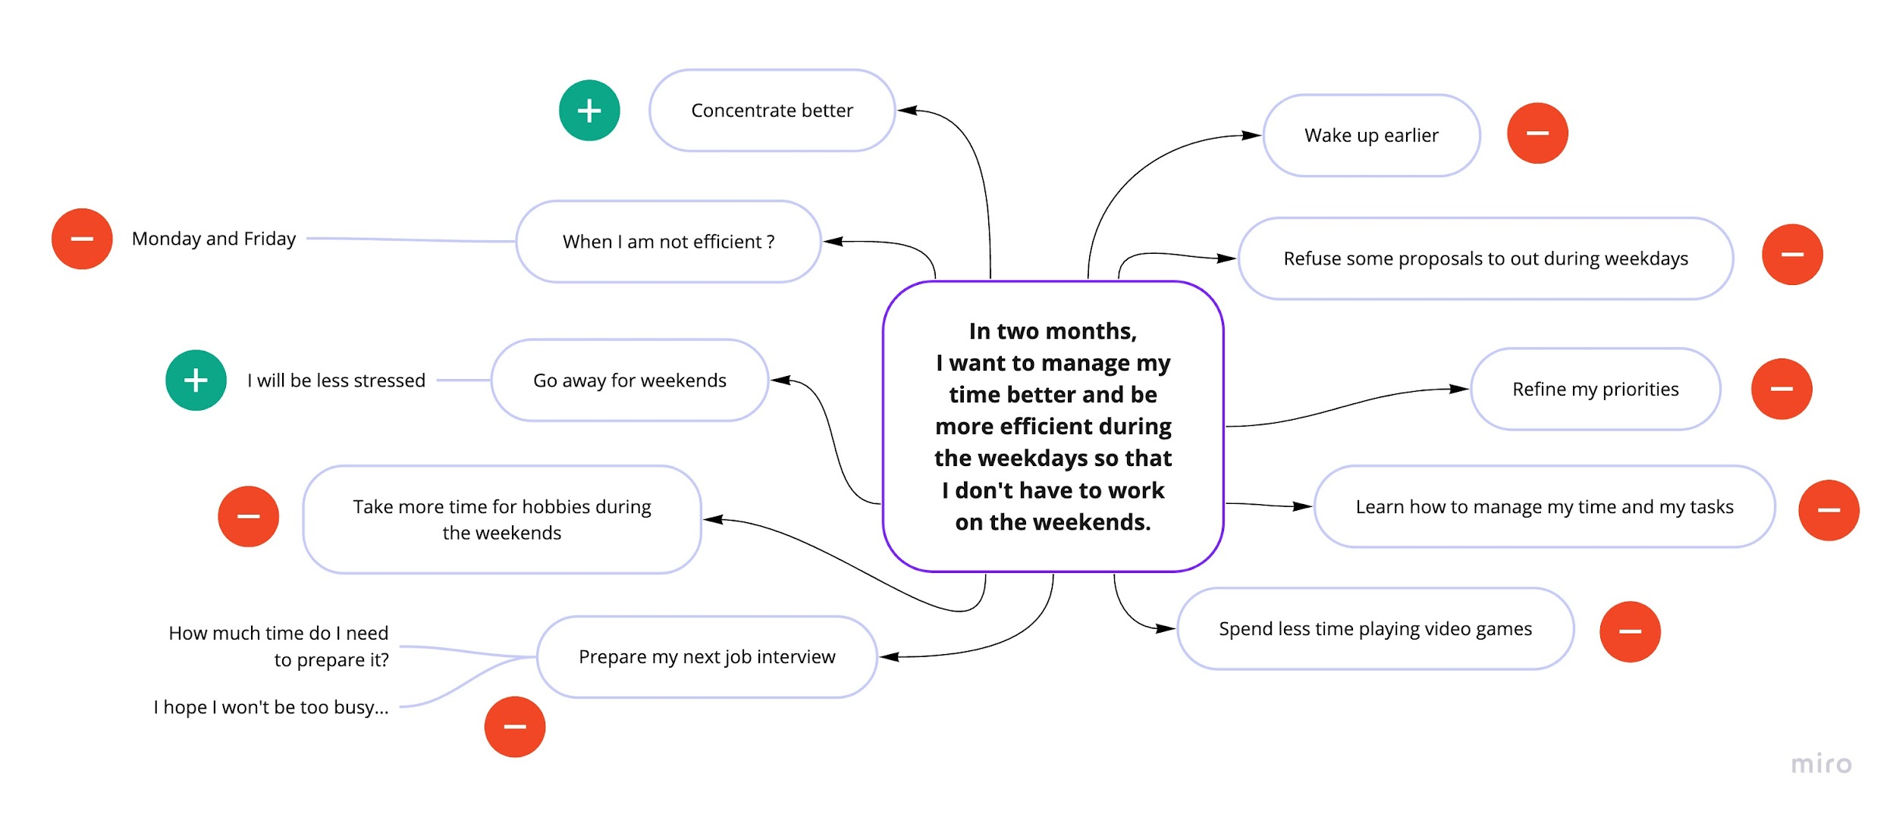Mind map - example*

*Have you finished? Let's go on.*

#### ***Step 5 – Cultivate Counter Thoughts***

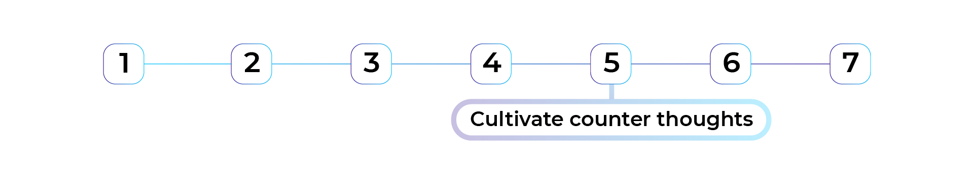

*You are now going to erase the* ***parasitic thoughts using*** *your* ***mind map*** *as* ***a roadmap.*** *How?*

*For each of the parasitic thoughts, you'll form a* ***counter thought.*** *It means looking at your parasitic thinking from another angle to find a more optimistic one.*

*Let's go back to my mind map on time management. The thought "Getting up earlier in the morning" is a parasitic thought that gives me a rather unpleasant emotion. I can challenge it with a counter thought: "I'll be able to get more things done during my day."*

*It's helpful to take enough time to think about each of your thoughts so you can identify other ones that could be attached to them.*

*Have you finished? 🥳*

*Complete this exercise:* ***imagine as many counter thoughts that you can cultivate daily.*** *By repeating them, these thoughts will sow positive emotions. And that's what you need to take action! 💪*

#### ***Let's Recap!***

*In this chapter, you've explored visualization techniques:*

* *Visualization allows you to get closer to your goal by* ***preparing your brain*** *to achieve it.*
* *You can use* ***mind mapping*** *to represent any thoughts about your goal.*
* *Identifying which thoughts bring up pleasant and unpleasant emotions helps you take stock of your* ***emotional weather forecast.*** *The negative ones are called* ***parasitic thoughts.***
* *You have the power to erase your parasitic thoughts by formulating* ***counter thoughts,*** *which put you in a more* ***optimistic*** *place. You can practice cultivating them daily.*
* *This visualization stage puts you in the best position to take action. Let's explore action in the next chapter.*

## ***3.3. Take Action to Achieve Your Goal***

#### ***Step 6 – Act Methodically***

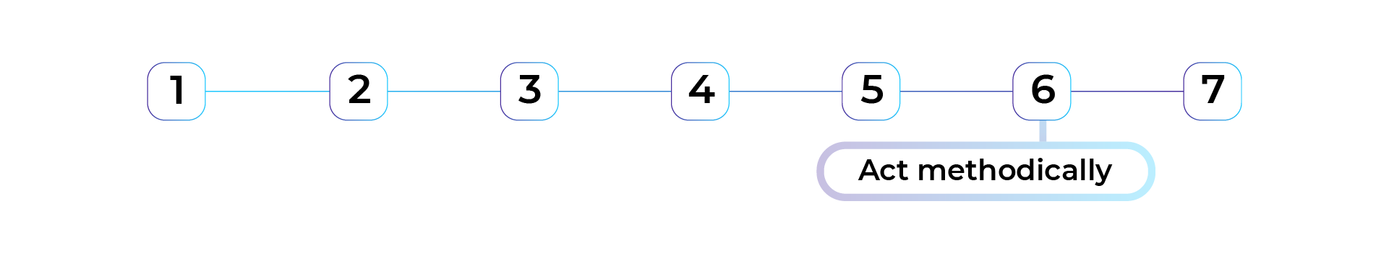

##### ***Take Baby Steps***

*Why "baby steps?"*

*A* ***baby step*** *is a* ***concrete action*** *that you can apply* ***even today*** *without disrupting your daily life. It is often* ***small actions,*** *when done* ***every day,*** *that bring you closer to your goal.*

*Let's go back to the goal of better managing my time. An initial baby step can be to read an article on time management.*

*Be sure to define your baby steps* ***as precisely as possible.***

*Being interested in the country's local culture where you want to find a job isn't specific enough to be a baby step. Instead, buy a book about the country's culture and that you'll read for 30 minutes this evening.*

##### ***It's Your Turn***



*Ready to take action? Go back to your goal and* ***define your next seven baby steps*** *for the* ***next seven days.*** *It will be your first cycle.*

*A baby step may be the same from day-to-day, but it can also be different. For example: "To improve my time management, tomorrow I'll try the Pomodoro method."*

*Once you finish this first cycle, define* ***seven new small steps*** *until you reach your goal.*

*I suggest you set* ***at least one baby step to complete every day,*** *but you can do more.*

*However, avoid actions that are too ambitious, as they could discourage you.*

##### ***Take Inspiration From Role Models***

*Another technique,* ***"act as if" actions,*** *consists of putting yourself* ***in the shoes of someone who has already met the goal*** *you want to achieve. You can mimic their* ***attitudes, reflexes, and habits.***

*For example, if my goal is to be organized, I'll put myself in the shoes of someone who is organized. Starting tomorrow, I'll act like an organized professional: I'll take at least 5 minutes every morning to review my schedule. That's when I realize that I don't have a planner. Therefore, I program a baby step: buy a planner or install an electronic calendar, which will also help me plan my next baby steps!*

##### ***It's Your Turn***

**

*Identify* ***three people*** *who typify the goal that you set for yourself. In our example, find inspiration from organized people. How do they behave daily? What habits have they established? Of course, you won't be able to replicate everything immediately. And that's not the point.* ***The goal is to be inspired to act by watching them.*** *It will also motivate you to take baby steps.*

*The more "act as if" actions you take with small steps, the more you'll move towards achieving your goal!*

#### ***Step 7 – Rely on the Buddy System***

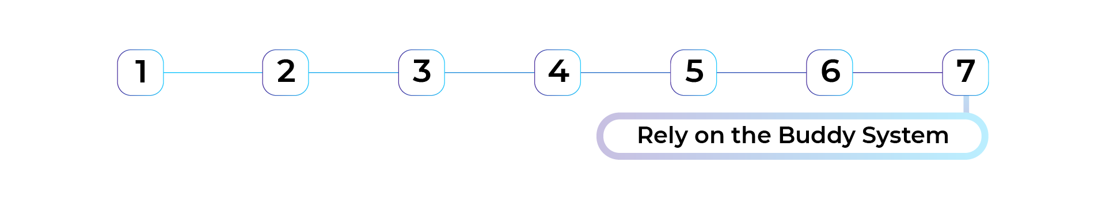

*To strengthen the six steps of this method, we recommend that you use the buddy system.*

*The buddy system is when two individuals support each other and move forward together.*

*Choose a* ***trusted person*** *who will be your "coach" and with whom you will* ***discuss your progress.*** *This person can be a loved one, a friend, or someone you discuss your baby steps. The person can motivate you to stick to it.*

*They can also help you change your negative parasitic thoughts. Checking in with this person regularly (at least once every two weeks) can be a baby step.*

#### ***Let's Recap!***

*In this chapter, you learned about several techniques to take action:*

* *The* ***baby steps*** *technique consists of identifying small steps to take each day for at least seven days.*
* ***"Act as if"*** *actions consist of putting yourself in the shoes of a person who has achieved your goal. It helps you replicate the attitudes, behaviors, and actions that bring you closer to this ideal.*
* *The* ***buddy system*** *builds on collective strength. It involves identifying someone who can support and coach you throughout your skill-building.*

*Congratulations, you have finished the course! You are now ready to develop your soft skills. Feel free to go to the* [*other OpenClassrooms courses dedicated to soft skills*](https://openclassrooms.com/fr/search?page=1&categories=Soft%20skills&language=en) *to continue your development by targeting the soft skills that will best help you achieve your goals. And don't forget: this is a lifelong process. By having taken this course, you've given yourself the keys to cultivating this continuous learning process. Continue on this path!*

# ***QUIZ***

# ***3.4. Are You Able to Create an Action Plan?***

### ***Evaluated skills***

* *Create your own action plan to develop your soft skills.*

### ***Description***

*Your friend Cindy has graduated as a developer and is looking for a job. She wants to give herself the best chance to succeed. Help her develop the soft skills that will help her achieve her goals!*

* ***Question 1  
  Cindy's goal is to find a job as a developer within two months. To achieve her goal, what are the three soft skills she will need the most?****Careful, there are several correct answers.*
  + *Communication*
  + *Organization*
  + *Stress management*
* *To find a job, Cindy will have to organize herself to manage her time, make appointments, communicate to enhance her interview profile, and manage her stress so that she doesn't get overwhelmed by emotions when faced with questions. Of course, other soft skills can be useful, but these three skills will have the most direct impact on her job search.*
* ***Question 2  
  Cindy needs to rephrase her goal to make it truly SMART. Which of the following proposals are correct goals?****Careful, there are several correct answers.*
  + *I want to clearly present my background and skills to pass at least one job interview within two months.*
  + *I want to organize my schedule better to meet at least two recruiters every week, within the next two months.*
* *The objectives in Answers 1 and 2 are correct: they contain a time indicator (within two months), they are focused on a specific soft skill, and are measurable.*
* *The objective in Answer 3 is not precise enough: it mixes two skills, communication, and organization. Cindy will struggle to reach it!*
* *The objective formulated in Answer 4 does not contain a time indicator: at what point does Cindy want to see the results of her progress?*
* ***Question 3  
  Cindy's goal is to clearly present her background and skills to get at least one job interview within two months. What do you advise her to do next?***
  + *To enter into a contract with herself.*
* *The next step is to confirm the sincerity of the objective by formulating a contract with herself. Cindy needs to make sure that she is aligned with her objective by validating the following idea: "I am not lying to myself when I set this objective." Commitment to the goal is a key step before taking action!*
* ***Question 4  
  Cindy made sure that her objective is sincere and wants to continue her plan of action. The next step is visualization. To help her visualize her skill development, what advice do you give her?****Careful, there are several correct answers.*
  + *To use the mind mapping technique to represent her thoughts.*
* *Visualization consists of creating a mental scenario of the future. Cindy will spontaneously write down all the thoughts that come to her mind when she thinks about her goal. She can use mind mapping to map out her ideas.*
* *However, it's not time to organize her thoughts or to call on other people. Cindy will move on to these steps later!*
* ***Question 5  
  What advice can you offer Cindy to make her mind map?****Careful, there are several correct answers.*
  + *To write her goal in the middle of her mind map.*
  + *Around the middle, to write down all the pleasant and unpleasant thoughts that come to mind.*
* *Cindy should write down her goal in the center: to clearly present her background and skills to get at least one job interview within two months. All around her, she notes all the spontaneous thoughts that come to her mind.*
* ***Question 6  
  Cindy realizes that her objective generates many unpleasant thoughts like failing in an interview, not knowing how to answer recruiters' questions, losing her place, etc. You tell her about "counter thoughts." Which of the following sentences are true?****Careful, there are several correct answers.*
  + *Counter thoughts are thoughts that provide positive emotions, or at least that are not unpleasant.*
  + *It is possible to create counter thoughts yourself, to be more optimistic.*
* *To help Cindy counter her parasitic thoughts, you can advise her to create counter thoughts. These will direct her mind to a more optimistic perspective and help her move forward. For example, "No matter what happens, I'm going to do my best," "I know what I'm doing better than anyone else, and I don't care how others look at me," or "I've already achieved similar goals, I can do it."*
* ***Question 7  
  Cindy's "indoor weather" has been done, now it's time for action! You advise her to take baby steps. To reach her goal of presenting her background and skills to land at least one job interview within two months. Which baby steps could she take?****Careful, there are several correct answers.*
  + *Presenting her background and skills to a friend in the next few days.*
  + *Meet with a developer recruiter to find out the most frequently asked questions during a job interview.*
* *Answer 1 is not a small step: sending ten applications in two weeks is an ambitious goal that seems far away!*
* *On the other hand, Cindy can practice in front of a friend or meet with a recruiter to ask questions: these two small steps are very accessible and allow her to progress.*
* ***Question 8  
  To take action, Cindy can also use the "act as if" method. How can she apply this method?***
  + *Cindy puts herself in the shoes of someone with strong communication skills and tries to change her attitudes and practices to "pretend" she is that person.*
* *The "act as if" method consists of being inspired by success, not of failure! Cindy can try to change a few habits and act "as if" she has already developed her communication skills. She would work on self-confidence, speaking out, etc.*